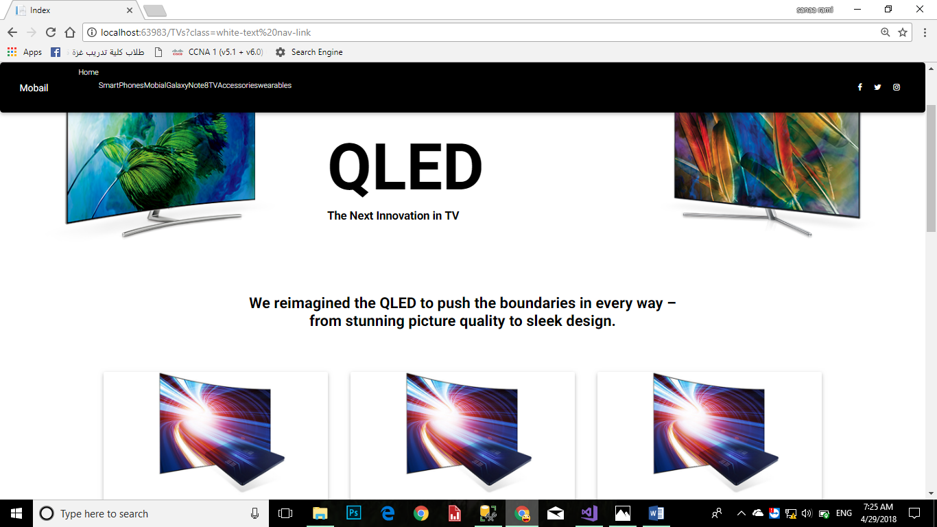

Page tV

This page works to display electrical devices, especially television

Add, delete, and modify data

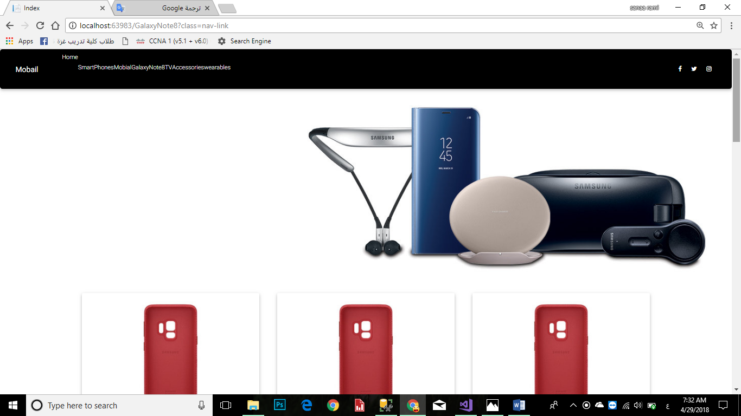

This page works to display electronics, especially mobile devices

Add, delete, and modify data

**And Jawalat have many types, including:Galaxy S+,Galaxy A5+ ……..**

**By details page**

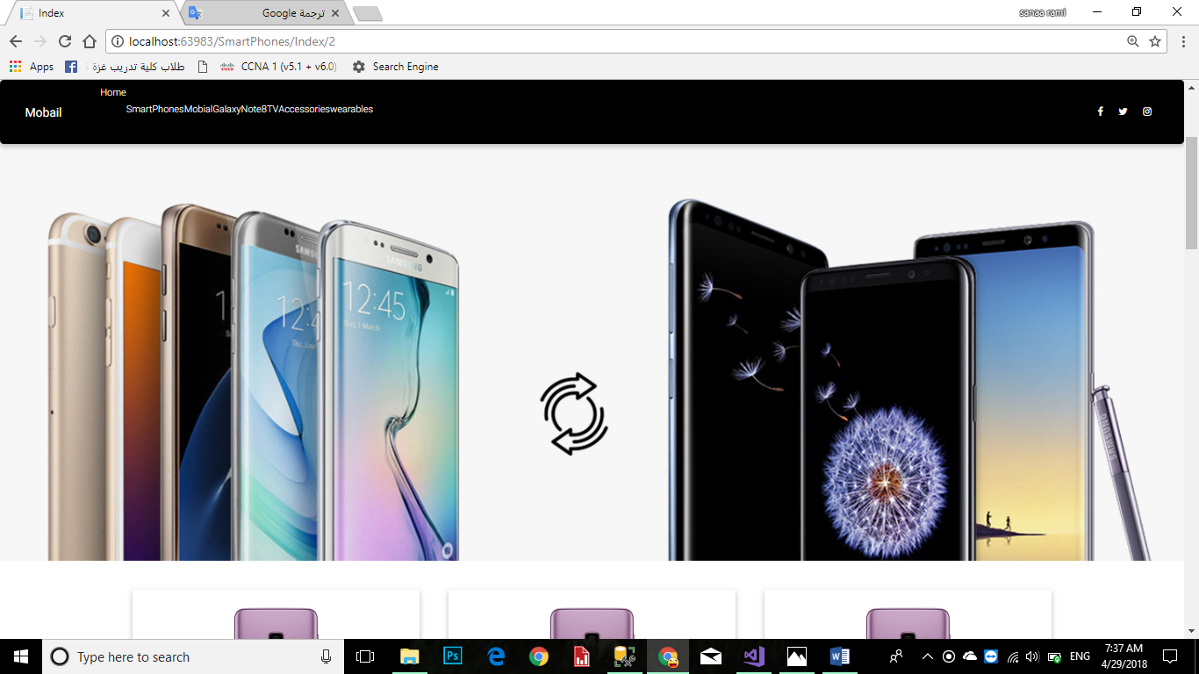

This page works to display electronics, especially mobile devices

Add, delete, and modify data

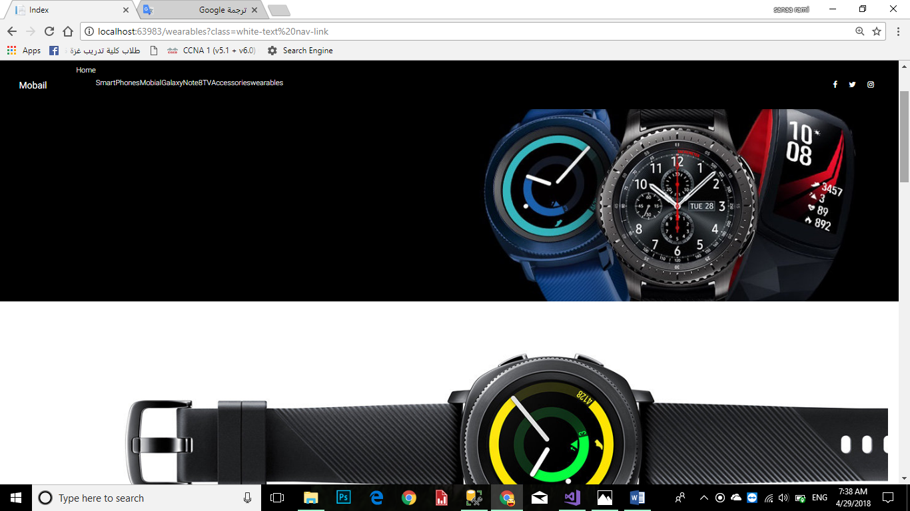

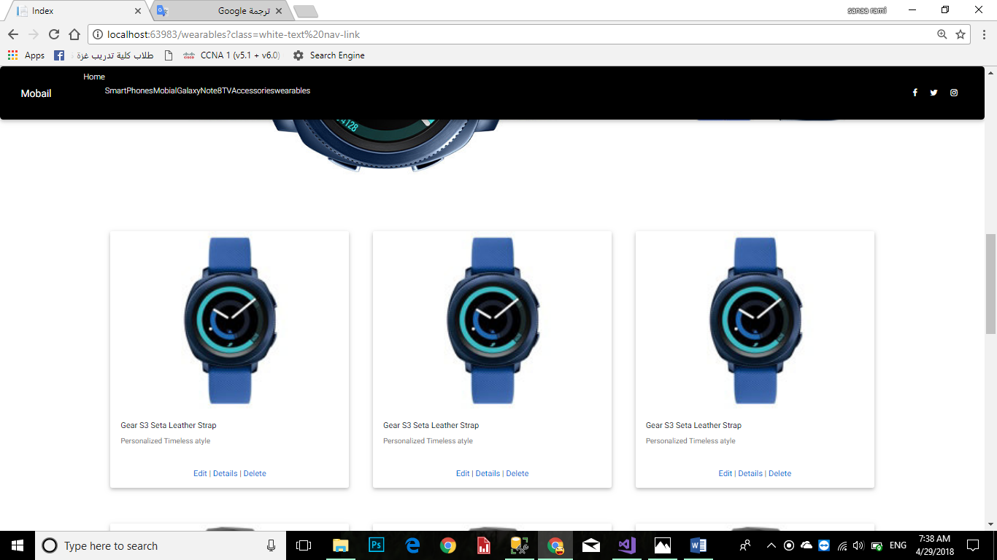

This page displays some electronic and electrical supplies such as clocks and

You create, delete, and modify

Such electronic supplies such as battery and others

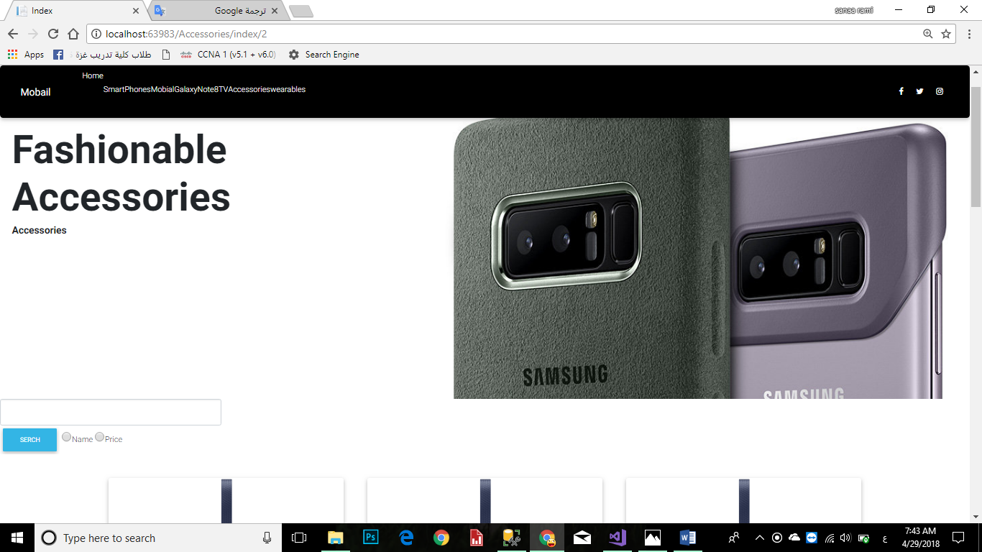

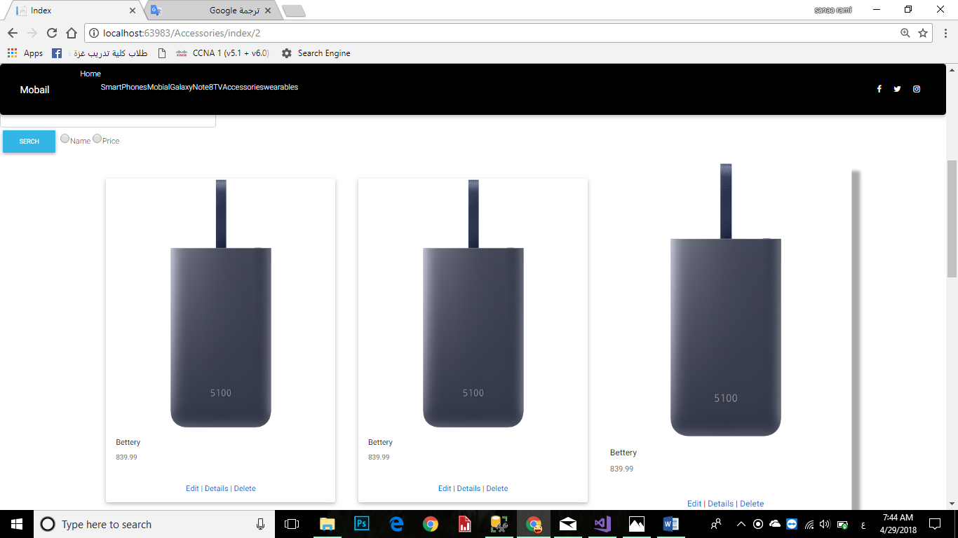

This page displays some electronic and electrical supplies

You create, delete, and modify

Such electronic supplies such as battery and others

--------------------------